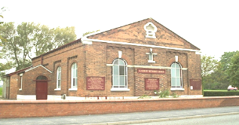
PETER Mmmhgg,3
GLAZEBURY METHODIST CHURCH

Minister: Rev Katharine Bland Tel: 01925 763218
Superintendent: Rev Wilfred Robinson Tel: 01942 523896
Church Contact: Delia Caswell Tel: 01942 671938
Circuit Website –– www.leighandhindley.org.uk
33

REVEREND KATHARINE BLAND 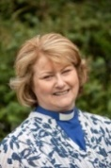

SUNDAY, 3 DECEMBER 2023 –First Sunday in Advent- Isaiah 64: 1-9; Psalm 80: 1-7; 17-19; 1 Corinthians 1: 3-9 and Mark 13: 24-37
+++++++++++++

Isaiah 64- New International Version
¹Oh, that you would rend the heavens and come down, that the mountains would tremble before you! ² As when fire sets twigs ablaze and causes water to boil,come down to make your name known to your enemies and cause the nations to quake before you!³ For when you did awesome things that we did not expect, you came down, and the mountains trembled before you.⁴ Since ancient times no one has heard, no ear has perceived,no eye has seen any God besides you, who acts on behalf of those who wait for him.⁵ You come to the help of those who gladly do right, who remember your ways.But when we continued to sin against them, you were angry. How then can we be saved?⁶ All of us have become like one who is unclean, and all our righteous acts are like filthy rags;we all shrivel up like a leaf, and like the wind our sins sweep us away.⁷ No one calls on your name or strives to lay hold of you;for you have hidden your face from us and have given us over to^{[b]} our sins.⁸ Yet you, Lord, are our Father. We are the clay, you are the potter; we are all the work of your hand. ⁹ Do not be angry beyond measure, Lord; do not remember our sins forever. Oh, look on us, we pray, for we are all your people.

+++++++++++++

HELP REQUIRED - The next Representative Synod will be taking place in our Circuit on Saturday, 20 April at Bedford Methodist Church. We will need volnteers to help in a number of roles - setting up, preparing hot drinks, car park stewards directing traffic from the main road etc. Unfortunately, this weekend clashes with the MWiB Weekend Away so a numbr of people from Bedford are unable to help out. If you would be able to volunteer, we would be incredibly grateful. Please could you let me know so that we can begin to make arrangements. Many thanks [Thomas Martin]

+++++++++++++

IF YOU HAVE KINDLY OFFERED TO PROVIDE FLOWERS FOR WHEN THERE IS A SERVICE AT GLAZEBURY COULD YOU PLEASE GIVE YOUR DONATION TO BRENDA. THE FLOWER ROTA LIST IS BELOW. IF YOU FEEL YOU DO NOT WANT TO CONTRIBUTE AS IT STANDS AT THE MOMENT, PLEASE LET ME KNOW. [Christine]

FLOWER ROTA –
DECEMBER 2023 – JANUARY 2024
DATE | NAME
3 December | At Culcheth
10 December | Robert Graham
17 December (evening) | Brenda Dodd
25 December | Delia Caswell
31 December | Circuit Service
2024 – 7 January | At Culcheth
14 January | Fiona and John Martin
21 January | At Culcheth
28 January | Sylvia Wilkinson

+++++++++++++
GLAZEBURY , CULCHETH AND CIRCUIT DATES FOR YOUR DIARY

GLAZEBURY NEWS/DATES –

COFFEE MORNINGS WILL NOW BE HELD ON 2ND AND 4TH TUESDAYS IN THE MONTH. 10.00AM – 12NOON. PLEASE NOTE.

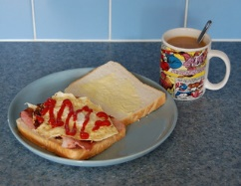

The next MEN’S BREAKFAST is on Saturday, 9 December 2023 at the usual time. NOTE – change of date.
18.30 Praise – No more 18:30 Praise services until the New Year.

Saturday Lunches – ‘Christmas style Lunch’ – Saturday, 9 December 2023.

The Rockets – following the success of their last performance – the Rockets are doing another Music Night on Friday, 15 December – tickets from Janet and Alan Crozier.

++++++++++++++

CULCHETH NEWS/DATES –

Monday - Prayers and Coffee - Prayers at 10am and Open Doors Coffee 10.30 till 12 mid-day, will continue every Monday during August. All welcome. Jane Bushby.

Saturday Coffee Shop The Coffee We have a lovely group who enjoy coming for a brew and a tea cake with good fellowship. They would love to welcome more people joining them. Do please come and bring family and friends. David Ogilvy

Meeting Point 7 December Christmas Celebration We are always keen to hear any ideas for future meetings. Joyce Davies and David Ogilvy

TakeTime Together Meditations - The next Taketime Together Meditation will be next Sunday 24 September from 7.30-8.30pm at Culcheth Methodist Church and then on alternate Sunday evenings from then on.

CIRCUIT DATES

Sunday, 3 December – 6.30pm – Hindley Churches Together Choir: While Shepherds Watched – St John’s – Refreshments available. Free admission. Donations to Wigan and Leigh Hospice.
Tuesday, 12 December – 10.30am Chroistmas Coffee Morning – Astley and Tyldesley.
Wednesday, 13 December - 3.30pm – Christingle – Bedford.

SERVICES AT GLAZEBURY METHODIST AND CULCHETH METHODIST

Date | Preacher | Steward/s | Flowers
2023
3 December | Rev Katharine Bland Toy Service and Parade at Culcheth | N/A | N/A
10 December | Local Arrangement (Breakfast Church) | Janet Crozier and John Martin | Robert Graham
17 December | am – Alan Eaves at Culcheth  6pm – Carol Service at GBlazebury | Christine Taylor and Delia Caswell | Brenda Dodd
24 December | am – no service  7.30pm – Rev Katharine Bland (HC) at Culcheth | N/A | N/A
25 December | Rev Katharine Bland at Glazebury | John Martin and Delia Caswell | Delia Caswell
31 December | Circuit Service at Bedford | N/A | N/A

++++++++++++++

PRAYERS

Please CONTINUE TO REMEMBER IN YOUR PRAYERS -

- Dawn Cavanagh and her family.
- For all those innocent people in Palestine and Israel.
- For the homeless especially at this time of year.
- For those in pain waiting for crucial operations.
- For all those we know who need our prayers who perhaps do not want to be named.
- For our country, no matter what your politics are.

++++++++++++++++++

God of all that is, seen and unseen.

At the beginning of this day, make me attentive to the treasure you have in store and give me grace to be surprised. When the way is dark or unclear, be the glint to guide me on. In the midst of this day, enable me always to work towards your light and give me strength to be patient. When ife is difficult and progress slow, help me to know how much I am treasured by you. At the end of this day, show me again the treasures you and I have unearthed together and give me a thankful heart. Amen.
[Pru Cahill, Deacon, North Lancashire Circuit – From Hidden Treasures]

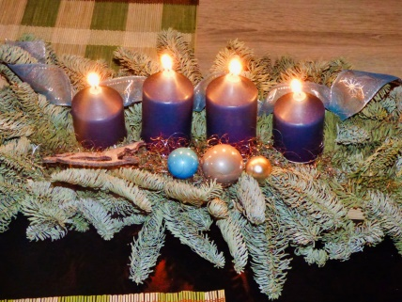
Wednesday 20th October
2021
10:00am - 1:00pm
Harwood Methodist Church
Bolton, BL2 3HX

Guest speaker: Revd Paul Martin
Conversation,
commissioning and communion

ALL WELCOME - Please bring a packed lunch,
D. - drinks will be provide
MWiB – District Day – 20th October
4?7&4&8:
&2"</"""=/""&+&44)2!+V&
%8&&'
E&&>78,&&&&&&%
4&&:'>%%
%>,&&&&8
&&4&&&&'>
8&&A&&&8%&:&
%'
*))&B%C
&8&%&%&&&
%&&&%&&&%&&'F@%8
W&&.'*%&'
(&,&+B>&C2#$%&'

Methodist Women in Britain
District Day.
Wednesday 20th October
2021
10:00am - 1:00pm
Harwood Methodist Church
Bolton, BL2 3HX

Guest speaker: Revd Paul Martin
Conversation,
commissioning and communion

ALL WELCOME - Please bring a packed lunch,
D. - drinks will be provide
MWiB – District Day – 20th October
4?7&4&8:
&2"</"""=/""&+&44)2!+V&
%8&&'
E&&>78,&&&&&&%
4&&:'>%%
%>,&&&&8
&&4&&&&'>
8&&A&&&8%&:&
%'
*))&B%C
&8&%&%&&&
%&&&%&&&%&&'F@%8
W&&.'*%&

