
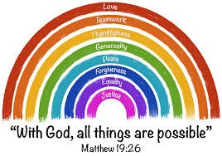
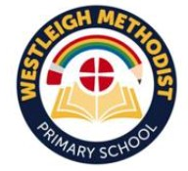
Westleigh Methodist Primary School
Circuit Meeting Report June 2026
We want to share the great things we have been doing at Westleigh Methodist Primary School in summer term 2025 - 26.
Visits out of school

Visits out of School

Liverpool World Museum
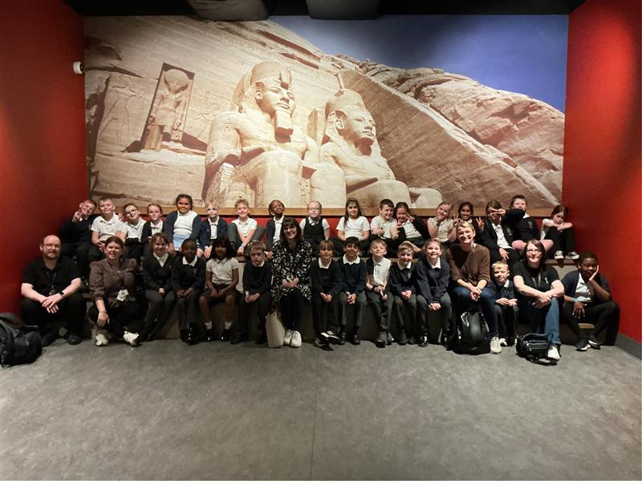
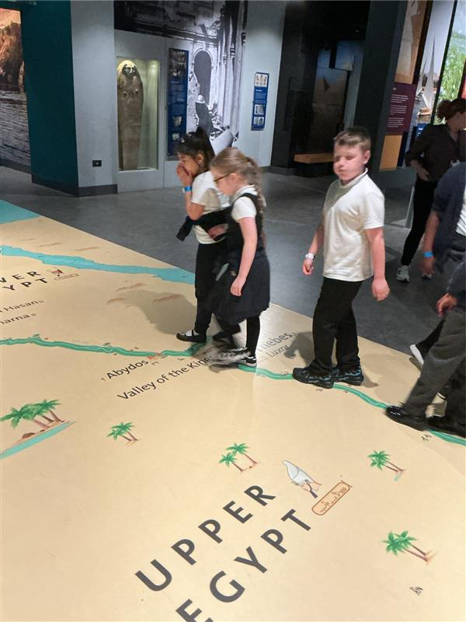
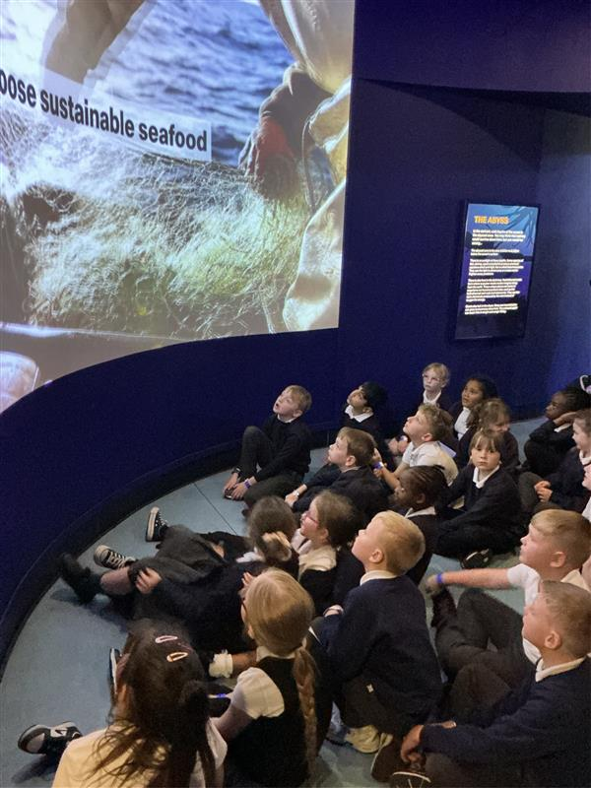
Year 3 visited Liverpool World Museum to explore many ancient artefacts. They dove into the aquarium looking at new species and interactive projections. They explored the story of life on Earth through a series of displays that took them on a journey around the world and through time to the beginnings of life itself, from the dinosaurs to the incredible animals living today. They also marvelled at the universe in the planetarium and learnt some interesting facts about our solar system. Linking to their learning topic, the children mostly enjoyed their time in the Ancient Egypt gallery where they learnt about ancient burial practices, read spells from the Book of the Dead and saw some mummies!

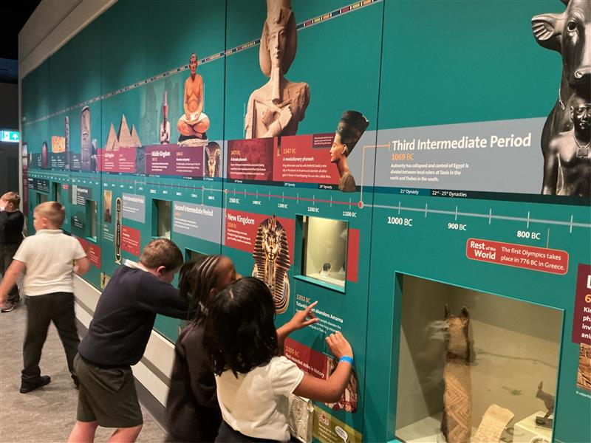

Spiritual Flourishing

Open the Book Worship

We were joined by some fantastic parishioners from our local methodist circuit who delivered an open the book worship to our school. Some of our children were invited to be part of the role play to share stories from the bible. The focus in this worship was Jesus’ calming of the storm, sharing the message that we should not let fear overcome us but instead face it and remain calm during the chaos.

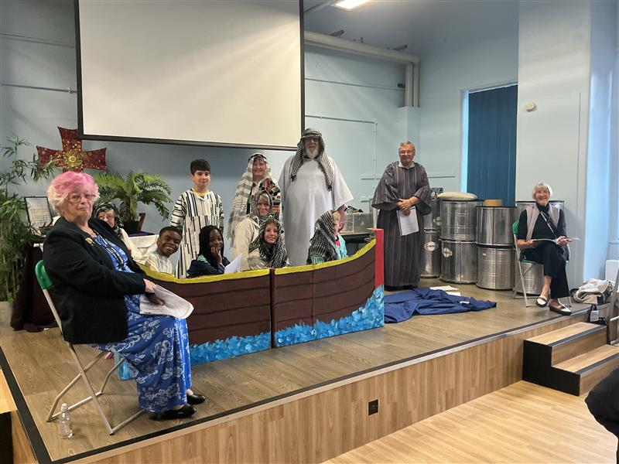
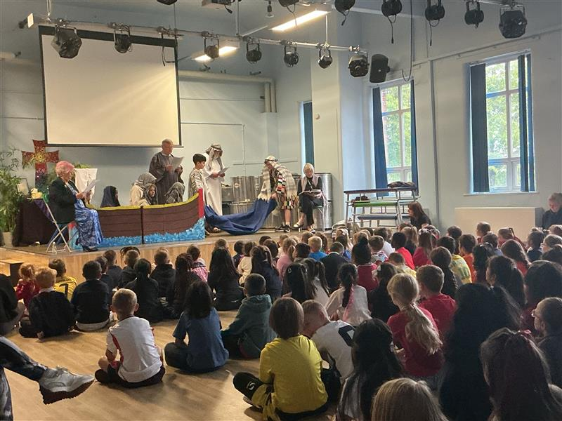

A Focus on Attendance
We are incredibly proud to recognise our children who have achieved 100% attendance—what a fantastic accomplishment! Here are just some of the children celebrated this week!
Bronze Badges have been awarded to those with 100% attendance this term—a brilliant effort and a great habit to build on!
Silver Badges go to our children who have maintained 100% attendance since September—an amazing demonstration of commitment and resilience!
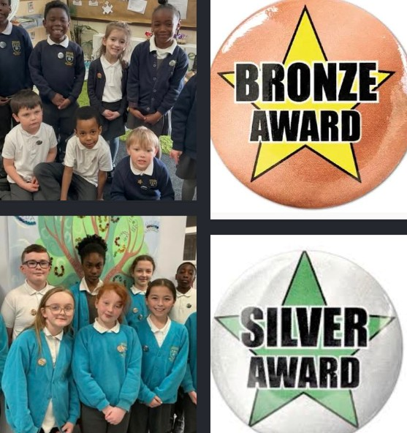
The Magic of Music!
Samba drums

Year 4 have had fun this last term learning some new instruments – the samba drums. Once they were over the initial shock of the loud sound, they enjoyed creating tunes and learning what different pitched sounds various parts of the drums can make.

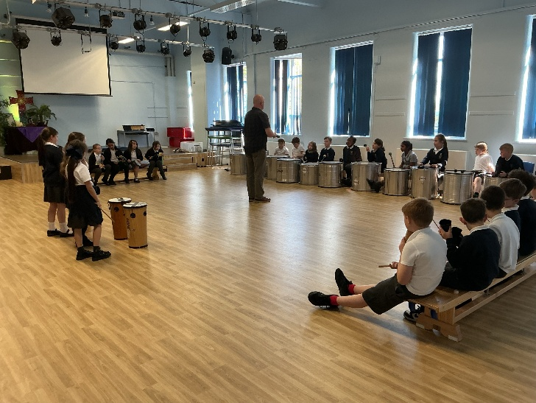
The importance of Emotional Health and Wellbeing

The Harmony Project

This term, the children in year 4 have progressed on to planting their tomato seeds. They are beginning to grow them in their classroom, on the windowsills before placing them into large planters to flourish outside in the sunshine.
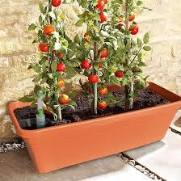
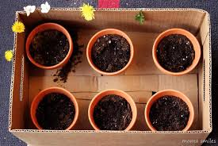

Bringing Learning to Life
Learning about balancing
Our Nursery children have been learning all about balance and how to try and make things equal weight.
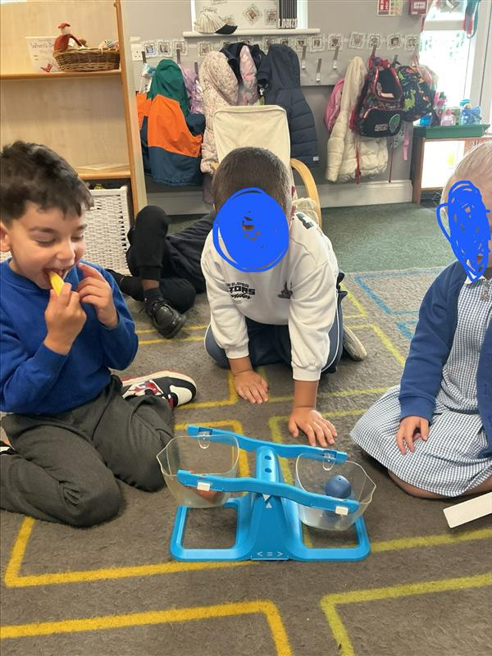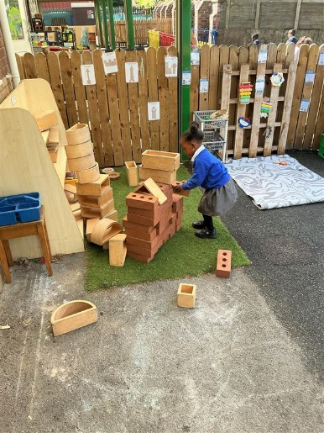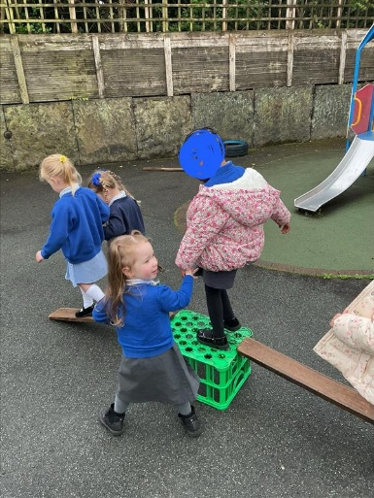

Being Geographers
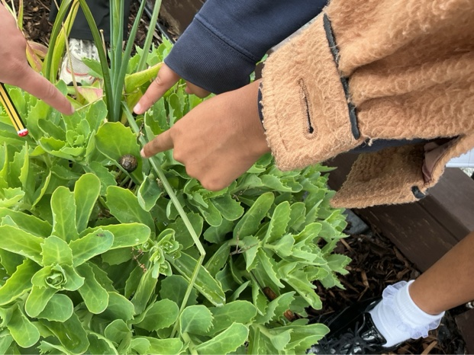
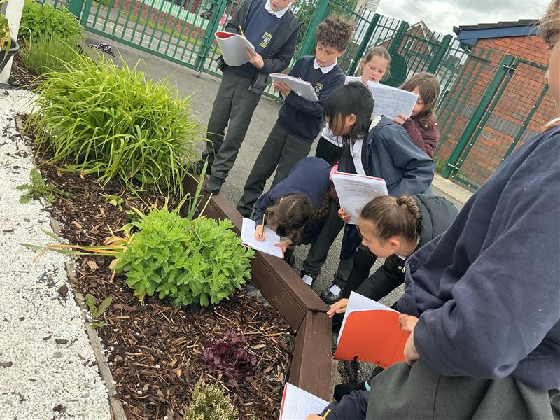
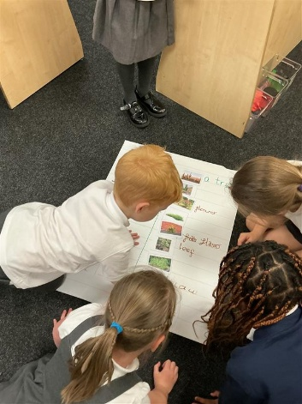
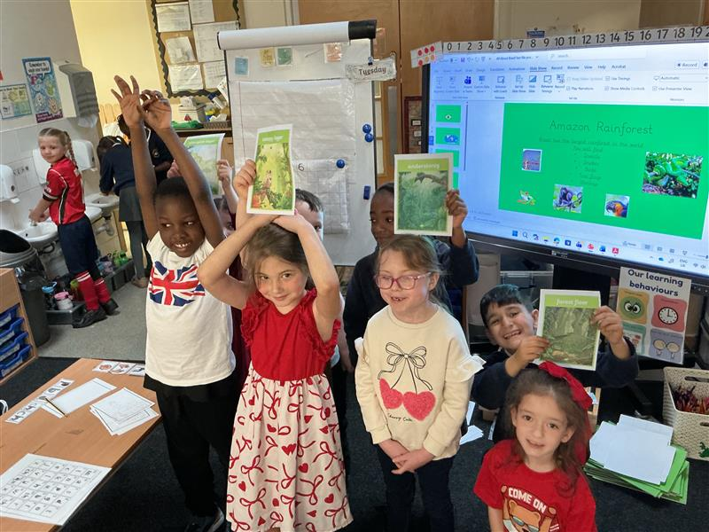
Year 1 have been learning all about the country of Brazil and finding out about the physical and human features that can be found there.

Young scientists
Year 4 have been investigating living things and did some fieldwork to research what living things we can find in our environment.

Exploring physics
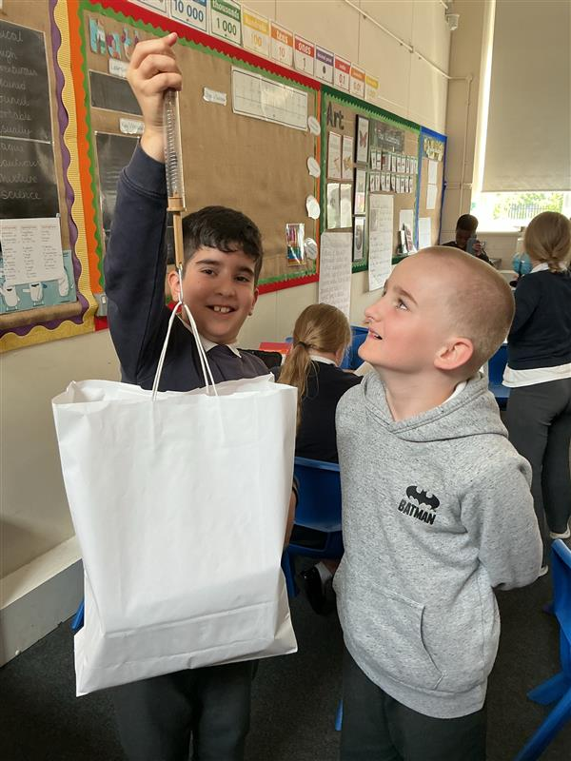
Yea 5 having have been learning about Newton’s law of gravity and conducting some of their own investigations into how gravity works.
