BOOKINGS FOR THE CHURCH AND COMMUNITY CENTRE
please ring Gillian Baglee on 01942 606630

ADDITIONAL EVENTS IN CHURCH
The Food Bank - Monday & Tuesday mornings
Mindfulness - Tuesdays
KINGSLEIGH COMMUNITY CENTRE

Monday | Slimming World | 5.15 pm
Tuesday | SWAP - Support for Wigan Arrivals Project  Kingsleigh Brownies | 11 am – 2.30 pm  7 pm
Wednesday | Kingsleigh Circle  Crossroads (second Wed. in the month) | 2 pm  Morning until lunchtime
Thursday | Kingsleigh Bowling Club outdoors from 21 April at Leigh Rugby Union Bowling Club. | 2 – 4 pm
Friday | Wrinkles & Dimples | 9.30 am – 12 noon

We continue to be responsible in our actions and cautious as a Church and as individuals, enabling us to show our care for others both for those inside our Church buildings and the wider community.

Sunday Link Update -The Sunday Link is e mailed to 35 members and contacts. It is photocopied every month for people coming to Church who cannot access e mail and copies are left in the foyer or at the back of Church for anyone to pick up. The Link also appears on the Circuit website. PLEASE, if you know anyone who is not receiving it, (especially those who are not on e mail) I would be grateful if you would take a copy for them. Thank you. Helen

All contributions for the May Sunday Link (available on Sunday 1 May)
to Helen please by Wednesday 27 April)
(Telephone 01942 519727 or e mail heoakes5@hotmail.com)

KINGSLEIGH METHODIST CHURCH

Minister: Reverend Wilfred Robinson
Telephone: 01942 523896
email: wilfred.robinson@methodist.org.uk

SUNDAY LINK
APRIL 2022

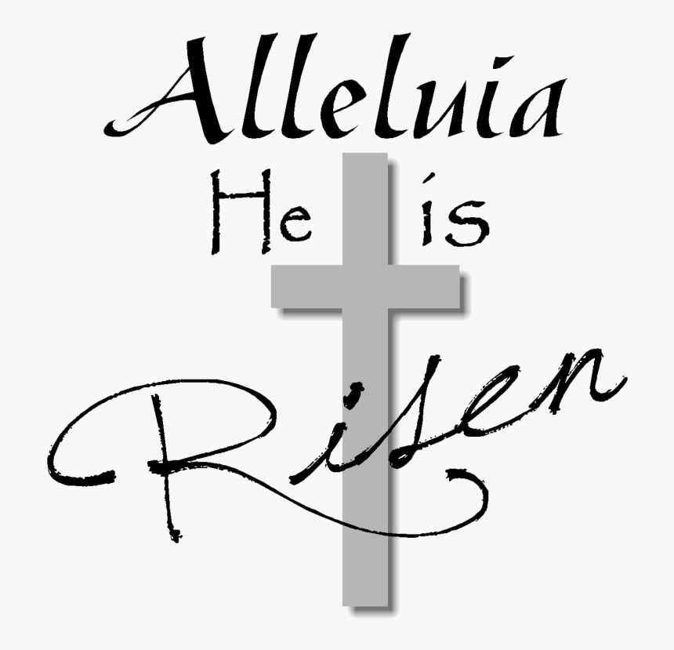
CHURCH SERVICES
3 April - 10.30 am – Mrs Susan Stewart
Easter offering envelopes will be available at this service.

HOLY WEEK
10 April - 11 am - PALM SUNDAY – At Kingsleigh - Circuit Service including Holy Communion – Revd Paul Martin (live stream)
14 April - 7 pm – Maundy Thursday – At Bedford - Circuit Service Reflection including Holy Communion – Revd Wilfred Robinson
15 April – 11 am – Good Friday – At Kingsleigh – United Service –
Revd Wilfred Robinson
17 April – 10.30 am Easter Sunday – At Bedford
Including Holy Communion - Revd Wilfred Robinson
24 April - 10.30 am – SONGS OF PRAISE
Please see the Notice Board and join in with the service by choosing and introducing your favourite hymn.

1 May – 10.30 am – Revd Sue Whitehead

CIRCUIT LENT COURSE – Revd Wilfred will be continuing with the sessions at Bedford on Thursday 31 March and 7 April at 7.30 pm
The sessions are available via zoom for those unable to attend in person. To access you need to use the same link/log in details for the Sunday service – please refer to the home page on the Leigh & Hindley Website.

During Holy Week from Monday 11 April 7 pm – 7.45 pm - also at Bedford - Revd John Fisher will be holding a series of Holy Week Reflections for the Circuit with on Maundy Thursday at 7 pm
the Circuit Service - Reflection and Holy Communion

We continue to remember and pray
for all those of our Church family and friends
who cannot attend Church through illness or other difficulties

Leigh & Hindley Methodist Church Circuit’s collection for the Ukraine Emergency Appeal

All We Can and the Methodist Church in Britain launched an emergency appeal in response to events unfolding in Ukraine. Working together with the Global Relationships Team of the Methodist Church in Britain, donations will be used to support the response to the crisis happening in Ukraine, and ensure that critical humanitarian assistance is available to those who need it. Kingsleigh’s collection for this appeal raised £462.57 (which included our March coffee morning proceeds). This has now been forwarded to the Circuit for onward transmission. Thank you to everyone who contributed. An update with the total of the Circuit’s final amount will appear in the next Sunday Link.
SUNDAY OFFERTORY ENVELOPES – These are now available in Church and via Kathleen.

WEEKLY EVENTS held in the Community Centre

KINGSLEIGH BROWNIES – Tuesdays 7 pm

KINGSLEIGH CIRCLE
6 April – Finding my Husband’s Auntie Eliza – Gwyneth Millard
13 & 20 April – No meetings (Easter break)
27 April – For Everyone Born the Right to be Free – Rev Anne Cash

KINGSLEIGH BOWLING CLUB – Thursdays 2 – 4 pm then from Thursday 21 April, Outdoor Bowling at Leigh Rugby Union Club,
Hand Lane, Leigh.

Please join us for our monthly Coffee Morning on
FRIDAY 1 APRIL from 9.30 am – noon
with tea, coffee, juice, toast and HOT CROSS BUNS and including a
‘Bits & Bobs’ stall and fund raising for Derian House.
We look forward to seeing you.

This will be followed on Friday 6 May with another
COFFEE MORNING!

