**GLAZEBURY METHODIST CHURCH**

**Minister:** Rev Katharine Bland Tel: 01925 763218

**Superintendent**: Rev Wilfred Robinson Tel: 01942 523896

**Church Contact:** Delia Caswell Tel: 01942 671938

**Circuit Website ––** [www.leighandhindley.org.uk](http://www.leighandhindley.org.uk)

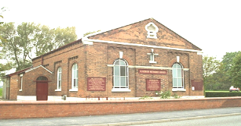

**REV KATHARINE BLAND** 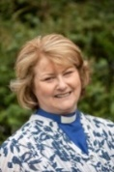

**SAD NEWS –Most of you will know by now, that sadly, Pat Turner passed away on Sunday, 30 January in Warrington Hospital. Pat was a regular worshipper at church. Our thoughts, prayers and condolences go to Paul, Pat’s husband, and all her family. Pat’s funeral will be at 3pm at Howe Bridge Crematorium on Wednesday, 16 February 2022. Afterwards at chapel for tea and coffee.**

*++++++++++++++*

**READINGS FOR SUNDAY, 6 FEBRUARY 2022 – Isaiah 6 (1-8; (9-13); Psalm 138; 1 Corinthians 15: 1-11 and Luke 5: 1-11**

**EXTRACT FROM LUKE 5: 1-11- ‘The Calling of the first Disciples ‘– One day Jesus was standing by the Lake of Gennesaret with the people crowding round him and listening to the word of God, he saw at the water’s edge two boats, left there by the fishermen, who were washing their nets. He got into one of the boats, the one belonging to Simon , and asked him to put out a little from shore. Then he sat down and taught the people from the boat…..**

*++++++++++++++*

**THIS IS A VERY IMPORTANT DATE IN THE FUTURE OF THE LEIGH AND HINDLEY CIRCUIT (YOUR CIRCUIT) AND GLAZEBURY METHODIST CHURCH – Can as many people as possible attend this event at Bedford Methodist Church. It is really important we have our say. We need your views. You do not have to hold a role within the church to attend.**

Following on from the Circuit Vision Day in October, the following prayer points were identified.

**The Circuit Vision: Implementation Day** will be taking place on **Saturday, 19 February 9 .30am — 12.30pm at Bedford Methodist Church**. Ahead of this we ask that you keep these seven points in your prayers. Each church will be given further information in organising opportunities for prayer ahead of the Implementation Day.

1. For the Circuit to identify as a team and to work more closely together.

2. To explore opportunities to share people and resources more closely.

3. To improve communication across the Circuit and between churches.

4. To provide pastoral support for our congregations and our staff.

5. To encourage opportunities to work closely with children and young people and our schools.

6. To explore opportunities to support our local communities.

7. To develop opportunities to support outreach work, including 'New People, New Place

*[Andrea (Circuit Office)]*

*++++++++++++++*

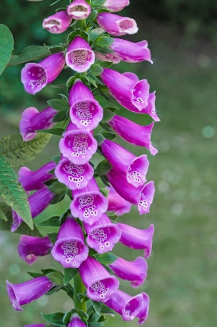

***The 2022 Flower Rota has been posted on the notice board in the church foyer. If you would like to take up one of the vacant dates then please speak to Brenda or Christine.***

***THANK YOU FOR THE FLOWERS IN CHURCH THIS WEEK PROVIDED BY COLIN MILLS***

***A PRAYER***

Lord of all, breathe through us your all-enfolding acceptance and grace that, being transformed by your holy purpose for us, we may accept with humility, respect with sincerity and love with tenacity all those with whom we are called into your fellowship. In the name of Christ, who forgives, heals and unites us. Amen.

**[Jenny Tunstall, Gordano Valley Circuit]**

*++++++++++++++*

**

**REVISED NOTICE**

**COFFEE MORNINGS** – The next Coffee Morning will be held on **Tuesday, 8 February 2022 – 10.00am – 12noon - If you can help with our Coffee Morning please contact Janet Crozier (Steward).**

*++++++++++++++*

**Rev Wilfred Robinson and Reverend Katharine Bland will be leading the Circuit Lent Course on Thursdays March 3rd, 10th, 17th, 24th, 31st and April 7th at Bedford Methodist Church 7.30pm. All welcome. This course will also take place on Zoom – details to follow. [Andrea, Circuit Office]**

*++++++++++++++*

***DATES FOR YOUR DIARY:-***

***Church Council Meeting – Thursday, 24 February 2022 – 7.30pm – please try and attend.***

***Circuit Meeting to be held on Thursday, 17 February 2022. Delia Caswell (for congregation) and Janet Crozier (for Stewards) to attend.***

***World Day of Payer – Friday, 4 March 2022 - 7pm at Newchurch Parish Church – Rupert Reece will take the service.***

***Pastoral Meeting-Wednesday, 9 March 2022 – (via Zoom or at Church?)***

***Harvest Festival – 2 October –hopefully at the allotment as last year.***

*++++++++++++++*

***SERVICES AT GLAZEBURY METHODIST***

|  |  |  |  |
| --- | --- | --- | --- |
| **Date** | **Preacher** | **Virtual (V) or Physical (P)** | **If you can’t attend church – join online by this link** |
|  |  |  | **Online**: click this link to join the meeting via **Zoom**. [Sunday Service Zoom Link](https://zoom.us/j/93584606158?pwd=VjcxWVBlVTg3NWs1NHRmQ1U0Wk9jUT09)  **On the Phone**: Dial **0330 088 5830** on your telephone,  When it asks for the access code, enter **935 8460 6158#**.  When it asks for your ID, press **#**. |
| **2022** |  |  |  |
| 6/2/22 | Maureen Hilton | P | **Steward** – Janet Crozier |
| 13/2/22 | Breakfast Church/ Local Arrangement | V | **Steward –** Christine Taylor |
| 20/2/22 | Live Stream/Local Arrangement | V | **Steward –** Graham Borg |
| 27/2/22 | Rev Wilfred Robinson (HC) | P | **Steward –**Delia Caswell |

***++++++++++++++***

**Please CONTINUE TO REMEMBER THE FOLLOWING in your prayers:-**

* **Pat Turner - who has recently passed away. For her husband, Paul, and all Pat’s family and friends.**
* **Eileen Groves – who has recently had a fall.**

**Those, for one reason or another, feel that they are not ready to return to church. May your blessings be always with them. For any of our friends and relatives who are finding these times difficult. May your presence be with them.**

***++++++++++++++***

Methodist Women in Britain

District Day.

Wednesday 20th October

2021

10:00am - 1:00pm

Harwood Methodist Church

Bolton, BL2 3HX

Guest speaker: Revd Paul Martin

Conversation,

commissioning and communion

ALL WELCOME - Please bring a packed lunch,

D. - drinks will be provide

MWiB – District Day – 20th October

4?7&4&8:

&2"</"""=/""&+&44)2!+V&

%8&&'

E&&>78,&&&&&&%

4&&:'>%%

%>,&&&&8

&&4&&&&'>

8&&A&&&8%&:&

%'

*))&B%C

&8&%&%&&&

%&&&%&&&%&&'F@%8

W&&.'*%&'

(&,&+B>&C2#$%&'

Methodist Women in Britain

District Day.

Wednesday 20th October

2021

10:00am - 1:00pm

Harwood Methodist Church

Bolton, BL2 3HX

Guest speaker: Revd Paul Martin

Conversation,

commissioning and communion

ALL WELCOME - Please bring a packed lunch,

D. - drinks will be provide

MWiB – District Day – 20th October

4?7&4&8:

&2"</"""=/""&+&44)2!+V&

%8&&'

E&&>78,&&&&&&%

4&&:'>%%

%>,&&&&8

&&4&&&&'>

8&&A&&&8%&:&

%'

*))&B%C

&8&%&%&&&

%&&&%&&&%&&'F@%8

W&&.'*%&

**THE LEADERSHIP TEAM** **MEETS ON A REGULAR BASIS**. **IF YOU HAVE ANY QUERIES/QUESTIONS PLEASE LET ME KNOW WHAT THEY ARE AND I WILL TAKE THEM TO THE MEETING – IT DOESN’T MATTER WHAT THE QUESTION/CONCERN MIGHT BE. WE CANNOT WORK FOR YOU IF YOU DON’T TELL US WHAT YOU MAY BE CONCERNED ABOUT!!!** *[Christine Taylor]*

**+++++++++++++++**

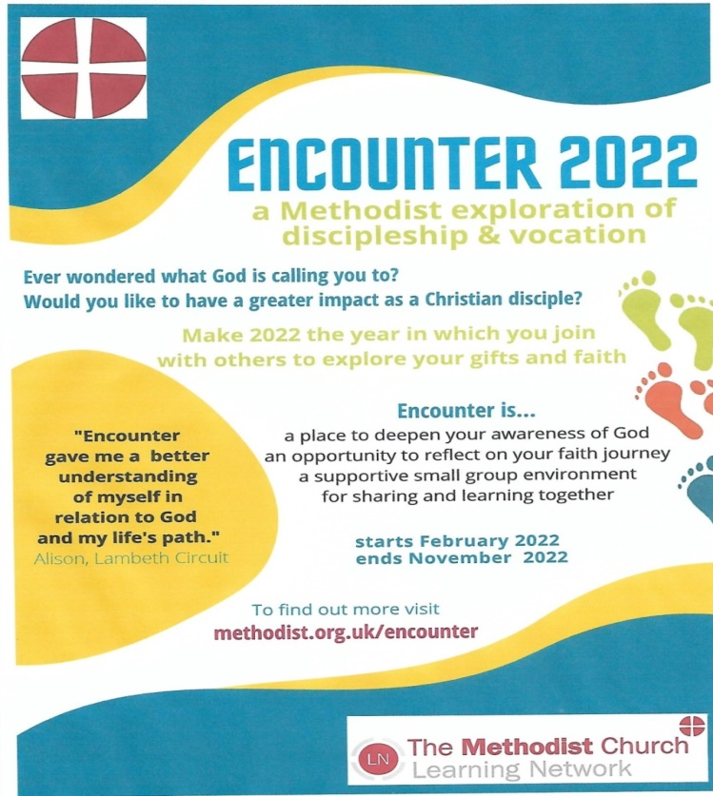

**Room / Event Bookings**

With immediate effect please direct all room / event booking enquiries to Robert Graham via one of the following methods: DM via the Glazebury Methodist Church Facebook page

By email: [Robert.graham5@sky.com](mailto:Robert.graham5@sky.com) By Phone or text: 07806 600508

***++++++++++++++***

For the most up to date news see our Facebook page.

Search ‘Glazebury Methodist Church’ on Facebook.

|  |  |
| --- | --- |
|  |  |

**IF YOU WOULD LIKE TO CONTRIBUTE TO YOUR NEWS SHEET PLEASE CONTACT ME - CHRISTINE TAYOR –ON 07801252625 OR** [**christine4872@sky.com**](mailto:chrisine4872@sky.com)

