**GLAZEBURY METHODIST CHURCH**

**Minister:** Rev Katharine Bland Tel: 01925 763218

**Superintendent**: Rev Luke Smith Tel: 01942 665654

**Church Contact:** Delia Caswell Tel: 01942 671938

**Circuit Website ––** [www.leighandhindley.org.uk](http://www.leighandhindley.org.uk)



**OUR MINISTER – REV KATHARINE BLAND** 

**Unfortunately, Rev Katharine has been advised to take further time off work. She is obviously not feeling well and we send her our love and continuing prayers and hope she feels better soon.**

**+++++++++++++**

**BIBLE READINGS for Sunday, 2 May 2021– Fifth Sunday of Easter – Acts 8: 26-40, Psalm 22: 25-31, 1 John 3: 16-24 and John 15: 1-8**

**Extract from Acts 8: Philip and the Etheopian – Now an angel of the Lord said to Philip, Go south to the road – the desert road – that goes down from Jerusalem to Gaza. So he started out, and on his way he met an Ethiopian eunuch, an important official in charge of all the treasury of Candace, queen of the Ethiopians. This man had gone to Jerusalem to worship, and on his way home was sitting in his chariot reading the book of Isaiah the prophet. The Spirit told Philip, ‘Go to that chariot and stay near it’………………..**

**+++++++++++++**

**The Pastoral Meeting will be taking place on Zoom on Thursday, 6 May at 10.00am. ZOOM ID – 850 5112 3068**

**+++++++++++++**



 ! "#$ 

%

%&'(

)*

(   +

,-" "./,,,

0%

""1,,2 "34

"0%

5                  #  67841

$   %

9,,,! 67841

%

,

%





 ! "#$ 

%

%&'(

)*

(   +

,-" "./,,,

0%

""1,,2 "34

"0%

5                  #  67841

$   %

9,,,! 67841

%

,

%





 ! "#$ 

%

%&'(

)*

(   +

,-" "./,,,

0%

""1,,2 "34

"0%

5                  #  67841

$   %

9,,,! 67841

%

,

%



**THE LEADERSHIP TEAM** IS MEETING ON A REGULAR BASIS. **OUR NEXT MEETING IS THURSDAY, 6 MAY.** **IF YOU HAVE ANY QUERIES/QUESTIONS PLEASE LET ME KNOW WHAT THEY ARE AND I WILL TAKE THEM TO THE MEETING – IT DOESN’T MATTER WHAT THE QUESTION/CONCERN MIGHT BE.**

*[Christine Taylor]*

*++++++++++++++*

**REOPENING FOR WORSHIP AT PENTECOST**

The Church will reopen for worship on Sunday 23rd May

The time of the service is to be confirmed.

The service will be led remotely by Rev Katharine Bland live from Culcheth Methodist Church.

If you’re unable to come, you will be able to view online.

All social distancing and Covid legislation will still apply.

Numbers allowed to attend are limited and we will operate on a first come first served basis.

The Coffee Hut will be open outside after the service.

Sunday 30th May will be Katharine’s first service in our church. Again, seats will be limited. We will let you know if pre-booking is required nearer the time. The service will be available to view online.

**COFFEE HUT**

We have been opening on at weekends in April and it is proving a great success in enabling us to reach out to the community.

We are open this Bank Holiday weekend on SUNDAY and MONDAY from 11am – 3pm.

Please note that we’ve changed the times.

Why not call in for a coffee, tea or hot chocolate and there may even be some home made cake available too.

Whilst we make no charge for the drinks, we do not turn away donations – people have been very generous - £2 / £3 /£5 for a coffee!

We are not handling cash but there is a sealed donation bucket that you can stick it in or we can take contactless card payments.

We’d like to carry on with the Coffee Hut each weekend in May, Saturday, Sunday or both, but can only operate with volunteers (full training will be given – don’t worry, it’s not difficult).

If you help for at least an hour, please let me know.

Thanks

Robert (07806 600508)

**+++++++++++++**



**Please CONTINE TO REMEMBER THE FOLLOWING in your prayers:-**

**Reverend Katharine and her husband Paul** as they recover from Coronavirus. We wish them both well – AND TAKE IT EASY!!!

**Edna and David Barlow** - Please still keep Edna and David in your prayers.

**Eileen Groves** – who is coming to the end of her radiotherapy treatment at Christie’s.

**Jan Newton** - Please remember Jan who, following a successful knee operation in January, has recovered sufficiently to allow her to have the other knee replaced quickly.  Jan had her operation on the 23 April so please keep her in your prayers and we look forward to another speedy recovery. We must all continue to support the NHS who have received bad press recently for the backlog of cases due to the pandemic but can still offer a remarkably good service and don't deserve a lot of the criticism levelled at them. *[Alan Crozier]*

**Rev Sue Whitehead and husband Neil**. Neil was taken ill last weekend. Please keep them and their daughter, Imogen, in your prayers.

**June Battersby and her husband**. Her husband was also taken ill last weekend.

**ALSO** – Let us remember anyone we know of that is suffering at this time of year whether from illness, mourning or mental health problems. They are all in our prayers.

**IF THERE IS ANYONE YOU KNOW OF WHO NEEDS OUR PRAYERS PLEASE LET ME KNOW (WITH THEIR APPROVAL) AND I WILL INCLUDE THEM IN THE LIST. THEY DON’T NEED TO BE MEMBERS OF OUR CHURCH.**

**++++++++++++**

**DELIA’S RECIPE -**

**KEEMA SPICED COTTAGE PIE – INDIAN SPCES WITH A BRITISH CLASSIC**

It is from the magazine ‘Simple Needs’ which Delia’s daughter-in-law, Tina, buys for Delia as a Christmas present. Both of them spotted the recipe in February (Tina in America and Delia in Glazebury) and thought the same – this looks good.

**HERE IS THE RECIPE:-**

**RECIPE FOR 4**

**INGREDIENTS:**

1 tablespoon of vegetable oil, 1 medium onion finely diced, ½ teaspoon of ground turmeric

2 tablespoons of garam masala (optional), ½ teaspoon of cumin seeds, 2 garlic cloves minced

2 teaspoons of fresh root ginger, 2 red chillies finely chopped, 500 grams of minced beef

1 tin of chopped tomatoes, 300 grams of frozen peas (defrosted), 25 grams of coriander

1 kilo of potatoes cut into chunks, 150 mils of milk, 80 grams of unsalted butter, 1 teaspoon of ground turmeric and 1 egg yolk

**METHOD:**

Pre-heat oven to 200 or 180 in fan over or gas 6. Heat the oil in a frying pan over medium heat. Add the onions and sauté for 10 minutes. Add turmeric, garam masala and cumin seeds and toast for 2 minutes. Then add garlic, ginger and chillies and sauté for a further 5 minutes until soft and slightly brown.

Fry beef and sauté until any liquid has evaporated. Add tomatoes and cook for a further 15 minutes. Add peas and coriander leaves and season. Spoon into an ovenproof dish. Leave to cool.

Potato topping – boil potatoes in salted water for about 20 minutes or until soft, then drain. Add milk, butter and turmeric and mash together. Put in egg yolk and mix well. Spread potato topping over the mince and ruffle the surface. Place dish in oven and cook for 30 minutes or when mince mixture bubbles at sides.

**ENJOY**

**+++++++++++++**

**YOUR PERSONAL INVITATION TO -**

**GLAZEBURY WEEKLY SATURDAY COFFEE MORNING- It’s just like a TUESDAY morning at church – join in and a have a chat. We miss YOU ALL so we would love to see you.**

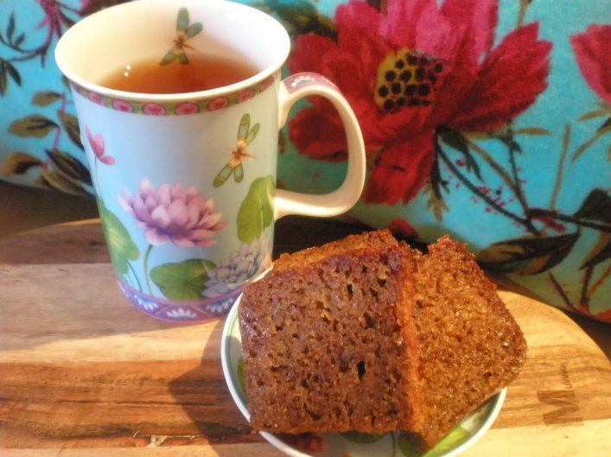

A time to get together to see each other and have a chat for an hour.

10.30am – 11.30am

on Zoom

**Meeting ID** – 840 7587 7165

If you’re not online why not connect by phone – 0203 481 5240 (using the same Meeting ID code)

**+++++++++++++**



**Topic: Quiz Night  
Time: 7 May 2021 8:00 PM**   
Join Zoom Meeting  
Topic: Quiz Night  
**Time: This is a recurring meeting Meet anytime**

Join Zoom Meeting  
https://us02web.zoom.us/j/89804710886?pwd=dE9IVm53WWNoZlUxQkYyQzU3am91Zz09  
  
**Meeting ID:** 898 0471 0886  
**Passcode:** 465850

**NB – QUIZ NIGHTS WILL BE HELD EVERY OTHER FRIDAY AT 8PM**

**+++++++++++++++**

**CULCHETH SUNDAY COFFEE MORNING – 11.30AM – 12NOON ENJOY A CHAT WITH OUR FRIENDS AT CULCHETH – ON ZOOM**

Note that this is now a repeating meeting – it will be the same link each week.

Join Zoom Meeting  
<https://us02web.zoom.us/j/88560759929?pwd=MFFDRittR0hkN0loWTlaTjlBN1V6UT09>  
Meeting ID: 885 6075 9929 Passcode: 012778

**++++++++++++++++++**

**SHARING SUNDAY WORSHIP - 10:30am**

**We are sharing our Sunday Service over the telephone, or online.**

**Online**, click this link to join via your internet browser. On a tablet or smartphone, download the Webex App, which it will prompt you to do: <https://mydanone.webex.com/mydanone/j.php?MTID=mcfe21c4f7df98fe26d8960c752cefd8b>  **OR Phone**: Dial 020 3478 5289 on your telephone, When it asks for the access code, enter 145 404 825#. When it asks for your ID, press #. The call will be charged at the standard UK phone rate

**++++++++++++**



**GOD IS STILL AT WORK EVEN THOUGH OUR BUILDING IS CLOSED!**