Welcome to Leigh and Hindley
July 2018
Kingsleigh Methodist Church
April 2018

Kingsleigh Methodist Church
Methodist Circuit Good News!
Ju January 2019
Bedford Events
Like most other churches in the Circuit, December was a very busy month.
We are fortunate to work closely with the school so a lot of our activities have involved them.
Breakfast with Santa, as ever, was very popular - it was chaos, but fun. Some of the schoolchildren joined us for the Carol Service and they, along with the ladies' choir entertained us very well. A lot of our congregation joined in an alternative 'Nativity Play' which conveyed the Christmas message in a very different format.
We had our usual fun Christmas party, and then on Christmas Eve, for the first time, we held an afternoon 'Carols, Candles and Communion' service. This too was a fun, but very spiritual occasion, with readings from two of the schoolchildren.
Some of our members enjoyed making angels for the festival at Kingsleigh and were delighted to be amongst the winners!
Our Christmas Day service, of course, is always very special with lots of family members getting together. This year we were entertained with a 'home grown' Christmas song provided by Rick and Jenny Wilson, with ukulele accompaniment (see picture).
Our Christmas Offering this year was donated to 'Mary's Meals' which is a very worthwhile cause. Somewhere in the region of £234 was raised and this is particularly pleasing as any money raised will be doubled.
The Covenant and Dedication Service on the 6th January also welcomed Andrea Metcalfe into membership of our church. It was a very special occasion.
On their return to school after the holidays, some of the children from the school have been busy creating the Prayer Corner at the entrance to our church. They should be justifiably proud of their achievements. (See picture). 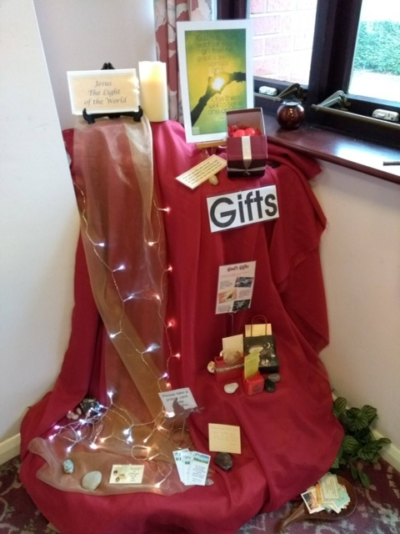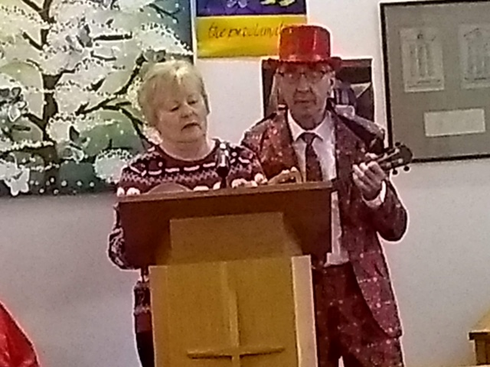

Upcoming Events

Wigan Road News

During the Christmas season we held a coffee morning with carols in the church with music provided by David Clifton on keyboard and Revd Andrew on trumpet.
It was the first time we'd tried it and it went down well.
Soon work will start on preparing spare land at the side of church to eventually become a wild life garden. Maybe by the next newsletter there will be something growing in it!

Hindley Green

During the Christmas period Hindley Green were entertained by two choirs.
Age UK Silver Choir performed on Friday 30th November and then Parkside Colliery Male Voice Choir entertained us on Saturday 15th December. Both were excellent yet different in their own way, and each evening was really well attended.
At the end of November, we held Messy Church at Westleigh Methodist School. Catherine and Revd John arranged the activities and church members and friends provided the support and prepared tea for all who attended. This was an extremely successful afternoon. Once again, with about 60 children and adults enjoying the fun-packed after-school event.
It is also worth sharing that through the generosity of members and friends we filled and sent 40 shoe boxes to Samaritan's Purse Operation Christmas Child!

Atherton Central
We enjoyed a wonderful fashion show with Fizz on the 17th October which was more popular than ever and early Christmas gifts were purchased.
Our WWI concert on the 17th November was beautifully poignant and moving and the church transformed for the occasion.
The Bolton Millennium Gospel Choir Christmas concert on the 12th December got us off to a very exciting Christmas period followed by our carol service and Christmas Eve service both in candlelight, very moving and well attended and led by our new minister Revd John Fisher.
Events from Culcheth

Our Church was quite a hive of activity in the run up to Christmas. In addition to supporting St Rocco’s Hospice through the local Christmas Postal Service, we were pleased to help Culcheth Christian Fellowship in using our premises as the local depot for the Samaritan’s Purse Shoebox Appeal, with the excitement of anticipating the joy of the recipients! On Christmas Markets Day, we provided refreshments, manned a stall and welcomed youngsters from the community into the church for Christmas crafts.
It was a joy to be allowed to retell the Christmas Story, using props and actions, to the pupils in ABC Preschool and to see their enthusiastic performance of ‘Shine Star Shine’, while the children in our thriving Mums and Tots group stole everyone’s hearts with their own interpretation of the Nativity!
At the other end of the age spectrum, Meeting Point members shared their favourite Christmas poems, songs and memories with each other. As well as the annual Toy Service, which was supported by the uniformed organisations, we enjoyed an inspiring variety of carol services, with evening advent services being shared with other churches and incorporating opportunities for quieter contemplation through words, images and music.

Kingsleigh
Kingsleigh are delighted to announce that Susan Mooney has now been accepted as a Worship Leader.
We wish her every blessing in this role.

We also celebrated, for the second year running, a very successful festive Christmas Lunch on
Sunday 16th December, attended by 51 people with lots to eat, plenty of chatter and a lovely atmosphere in the Community Centre.This was followed by a Carol Service in Church, based on poetry, led by Revd Vivienne and ending with carols sung by candlelight.
A truly excellent start, in the week before Christmas, with the Church family spending time and fellowship together.

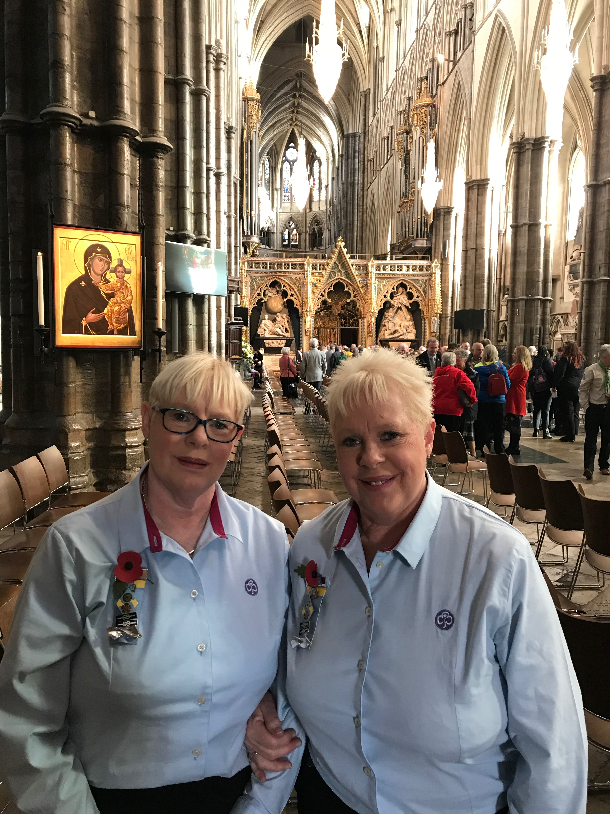
Kingsleigh Brownie leaders 40 years’ service recognised
Barbara Cain and Julia Fletcher have been involved with Kingsleigh Brownies for 41 years, this long service was recognised locally at a Division event in March.
Both were then thrilled to receive an invitation to a national Scout and Guide Service of Celebration and Thanksgiving that was held on Saturday 3rd November at Westminster Abbey. This was a gathering from across the country that filled the Abbey and highlighted the positive impact that Scout and Guide leaders have with so many young people.
They had prime seats by the tomb of the unknown warrior and had the privilege of talking to the Dean of Westminster prior to the service a week before he would be escorting the Queen in a special Remembrance Service at the same location. The service was memorable for the singing of the choir and the wonderful organ music. It also was an opportunity to reflect on the many Brownies and the other leaders and helpers that had been part of Kingsleigh Brownies over those 40 years.
Kingsleigh also celebrated, for the second year running, a very successful festive Christmas Lunch on Sunday 16th December attended by 51 people with lots to eat, plenty of chatter and a lovely atmosphere in the Community Centre. This was followed by a Carol Service in Church, based on poetry led by Revd Vivienne and ending with carols sung by candlelight.

News from Bag Lane

The adult choir performed “The Gift” which is a musical depicting the Christmas story which was very well attended. Also we had our “Christmas Tree Social” where the children sang carols. We also had “Carols on the Grass” which came about when a group of chaps from Wigan Council called the Bright and Boroughs had volunteered to paint our railings, cut the grass and plant flowers. As a result it was suggested we sing carols outside at Christmastime. Soup was served in church on the day, which was welcomed as it was cold! This was enjoyed by all who attended as it was something a little bit different.

‘Good News’ from Catherine, School Chaplain

Christmas is a busy time of year for all of us but especially so in schools with Nativity plays, carol concerts, Christmas fairs and so on. Some highlights from our two schools this year were the Christmas-themed Messy Church in Westleigh school hall put on by members and friends of Hindley Green Methodist. We had around 45 children and 25 parents/carers join in the fun with most families staying to the end and many of them expressing sincere thanks to the team.
In Bedford, the Nursery 3-4 year-old class tried something new with a Christmas Carol presentation in the Chapel in front of their grown-ups who were also invited to decorate biscuits with the children beforehand and enjoy hot chocolate afterwards! The nursery class value of Love was demonstrated by collecting items such as toiletries, gloves and socks to pass on to Helping the Homeless in Wigan.

Our new after-school club, Worship Warriors, was launched in Bedford in November through which a group of 5-10 children enjoy sharing Bible stories with the rest of the school using drama in whole-school collective worship. Also at Bedford, a new ‘service’ for all ages was launched on a Sunday afternoon at the end of January called S.M.I.L.E. – (Sunday Madness in Leigh for Everyone!). Four families plus others had lots of fun with parachute prayers, songs and jelly and ice-cream amongst other activities. A number of school families have expressed an interest in coming along to our next one on 24th February which we are all really looking forward to.

Glazebury Events
Glazebury Methodist Church decided to do something different instead of the traditional Carol Service back in December. On 23rd December we held a Community Christmas Singalong at 6pm. We set up the church to allow very informal sitting and standing with the doors wide open into the front garden where there was a welcoming fire with roasted chestnuts and you could help yourself to hot mulled punch or tea and coffee and mince pies. The combination of Carols and Christmas songs were relayed on both the screen inside the church and projected onto the outside walls of the church to be seen from the garden/car park and roadside by passing traffic. The music from the organ or piano was relayed both inside and out to guide the singing. Poignant readings were slotted into place on just a few occasions. In excess of 120 people of all ages came along and joined in. This was a brilliant new venture which to quote one family that this had “really made a special meaningful start to their Christmas”. Thanks to those for the idea and to those who were willing to give it a go.
Held on the last Saturday morning of every month, the men's breakfast is still going strong. Encouraging local men to cross the church threshold, who would not normally come near a church. We make them welcome provide a simple breakfast and have local speakers who talk on various subjects.

Forthcoming Events:
Atherton Central

Thursday the 14th February kicks off our New Year of events with our “Valentine Evening”. Tickets available from 20th January 2019.
Saturday 23rd March we will again hold our very popular Good as New Sale
Integra Brass will entertain us on Saturday 30th March and tickets will be available shortly.
Bag Lane

Friday 15th February – “Garland of Melodies” concert
Sunday 17th February - Church Anniversary concert
Details from Mavis Power

Hindley Green
Wigan Ukulele Band will be performing on Saturday 23rd February at 7.30pm. Tickets available or pay on the door £5

Kingsleigh
Saturday 23rd February 2019 at 6 pm in the Community Centre - Tea Club, Fish and Chip Tea followed by a presentation on the Royal National Lifeboat Institution by D M Jones.
For further details, please ring 01942 519727.

St John’s
We are about to start an Alpha at Home Series where we will be using the Alpha Videos, but in a different way. There will be two introduction sessions on 26th February at 7.30pm and 27th February at 1.30pm.
For further details please ring 01942 660798.
Articles for the April issue of the newsletter to be submitted no later than Tuesday 26th March please – thankyou.

