**GLAZEBURY METHODIST CHURCH**

**Minister:** Rev Katharine Bland Tel: 01925 763218

**Superintendent**: Rev Viv Smith Tel: 01942 665654

**Church Contact:** Delia Caswell Tel: 01942 671938

**Circuit Website ––** [www.leighandhindley.org.uk](http://www.leighandhindley.org.uk)

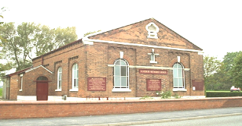

**Bible readings for Sunday, 28 February 2021– second Sunday in Lent – Genesis 17: 1-7 and 15-16; Psalm 22: 23-31; Romans 4: 13-25 and Mark 8: 31-38**

**Here is an extract from Mark 8: – Jesus Predicts His Death – He then began to teach them that the Son of Man must suffer many things and be rejected by the elders, chief priests and teachers of the law, and that he must be killed and after three days rise again. He spoke plainly about this, and Peter took him aside and began to rebuke him……**

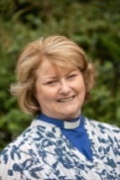 **Reverend Katharine Bland**

**+++++++++++++++++++**

**FROM OUR MINISTER – REVEREND KATHARINE BLAND**

Dear Friends,

I cannot begin to tell you how much I have missed you. The last two months have felt surreal, and not in a good way! The last things I can remember are Christmas Eve and Christmas Day. By the morning of 27th December Paul felt unwell and was offered a Covid test in Irlam. By late afternoon it was my turn, and Chris and I managed to secure tests at Haydock Park racecourse. So far Chris has had three negative tests, so it is highly likely that Chris had already had Covid sometime previous and been asymptomatic. Over the following days our results returned - Paul and I tested positive and now Chris was our nurse!

I don't really want to go into detail about our health, save to say that Paul and I have both been really poorly, probably the most poorly we have been in our lives. Never have we needed ambulance call-outs via 111 before, and in fact on the third occasion we received a call from ambulance control to advise us to transport Paul to A&E ASAP by our own means as there were no ambulances available in the North West. And so at 2am, on what turned out to be the most horrendous weather mix of sleet, snow, ice and flooded roads, we set off in the car to Warrington Hospital. As we arrived nothing could have prepared us for the sight of so many ambulances with patients in them receiving treatment. Chris and I weren't allowed to accompany Paul beyond the doors, so we waited in the car for Paul's text messages. A few hours later he asked for his overnight bag, as they needed to admit him with severe post-Covid symptoms - something for which Paul is still in need of treatment.  As for me, Covid has affected my respiratory system. I still get breathless, even when resting, and the stairs leave me gasping. I am sleeping a lot, and pyjama days have taken on a whole new meaning!  Anyway, there you go. I'm not back to full-time ministry yet, but my GP is happy for me to have a 'take things easy phased return'.

Now for the really important bit ...

Paul and I would like to thank you all for all your thoughts and prayers, your cards, letters and flowers and answer-machine messages. Thank you for our prayer shawls, when our words have been lacking; thank you for our gifts home-made and bought, your love was woven into them; thank you for meals when we hadn't felt like cooking, and goodies when we hadn't felt like shopping; for your humour when all we wanted to do was cry; for hugs that came in the form of words and pictures when we were feeling anxious; thank you for the pictures and messages of hope which Hannah has displayed in the church windows at Culcheth - I feel blessed to be able to visit them daily; thank you for words of encouragement for all displayed at Glazebury, much appreciated when I pass in the car; thank you for planting those mini daffodils in the raised garden at Culcheth, they taught us that even the most delicate things have an incredible inner strength. Thank you also to everyone who has contributed articles for the church news sheets.

We have been overwhelmed by the outpouring of your love for us. Most of you we haven't even had the opportunity to meet yet. We thank you, all of you, and look forward to that time, which we pray will soon be upon us, when we can meet together safely. For now, here's to keeping safe, receiving the vaccine jabs, and encouraging as many young people as we can - for those returning to primary, secondary schools, colleges and universities. For those who are awaiting exam results, however they will be assessed; it is always a nervous time. For loved ones in care homes and hospitals whom we have not been able to visit. For our families and friends. For each other.

And a little bit of Martin Luther King Jr (and me!)

*"If you can't fly, then run. If you can't run, then walk. If you can't walk, then crawl. [If you can't crawl, let someone hold you.] But whatever you do, keep moving forward."*

God Bless,

Lots of love,

Katharine, Paul and Christopher xxx

**++++++++++++++++**

**CHURCH SERVICE ….**

**Here is your invitation to the next Evening Worship on Sunday 28 February at 6.30pm. This will be taken by Rev Len Pereira.**

**Join Zoom Meeting**<https://us02web.zoom.us/j/81456115209?pwd=eUhFL2IxbUV5OGlGeHVteTdzbFFYZz09>

**Meeting ID: 814 5611 5209  
Passcode: 229955**

**+++++++++++++**



 ! "#$ 

%

%&'(

)*

(   +

,-" "./,,,

0%

""1,,2 "34

"0%

5                  #  67841

$   %

9,,,! 67841

%

,

%





 ! "#$ 

%

%&'(

)*

(   +

,-" "./,,,

0%

""1,,2 "34

"0%

5                  #  67841

$   %

9,,,! 67841

%

,

%





 ! "#$ 

%

%&'(

)*

(   +

,-" "./,,,

0%

""1,,2 "34

"0%

5                  #  67841

$   %

9,,,! 67841

%

,

%



**LENT COURSE – PLEASE JOIN US – TO WATCH AND DISCUSS ‘THE GREATEST SHOWMAN’**

You are warmly invited to attend one of our Zoom sessions commencing on Saturday 20th February 2021 @ 10.00am https://us02web.zoom.us/j/82712878366?pwd=eG5ZcE1BYVlqbktSVzg4YXVDQjZIdz09 AT **CULCHETH**  Meeting ID : 827 1287 8366 Password : 759634

**OR GLAZEBURY** Tuesday 23rd February 2021 @7.30pm https://us02web.zoom.us/j/87410748216?pwd=N29wcVJWc00wT21ZQmNPajdpQjRLdz09 Meeting ID: 874 1074 8216 Password: 493271

**FORTHCOMING MEETINGS …..**

**FOR ALL PASTORAL VISITORS THERE WILL BE A PASTORAL MEETING VIA ZOOM ON THURSDAY, 4 MARCH 2021 AT 10.00AM. DETAILS HAVE BEEN SENT TO PASTORAL GROUP MEMBERS**

**+++++++++++++++**

**CHURCH COUNCIL MEETING – please note there is a Church Council Meeting (via Zoom) on Wednesday, 10 March 2021 at 7.30pm. CONNECTION DETAILS TO FOLLOW.**

**+++++++++++++**

**YOUR PERSONAL INVITATION TO -**

**GLAZEBURY WEEKLY SATURDAY COFFEE MORNING- It’s just like a TUESDAY morning at church – join in and a have a chat. We would love to see you.**

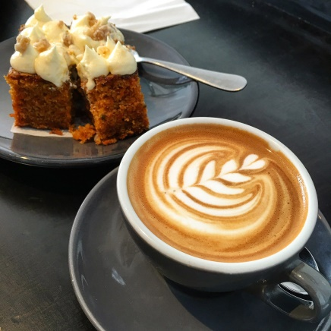

A time to get together to see each other and have a chat for an hour.

10.30am – 11.30am

on Zoom

Meeting ID – 840 7587 7165

If you’re not online why not connect by phone – 0203 481 5240 (using the same Meeting ID code)

**Everyone has been baking and cooking more during lockdown. How about sending in your favourite new/not so new recipes!!??? For example what is the best way to make pastry? I have cold hands but cannot make pastry!!!!!!!**

**+++++++++++++++**

**Topic: Quiz Night  
Time: 5 March 2021 8:00 PM**   
  
Join Zoom Meeting  
<https://us02web.zoom.us/j/82030030242?pwd=d2FEMGlzMUR1ODVpbDVrZWM0Z1JVZz09>  
  
Meeting ID: 820 3003 0242  
Passcode: 090323  
One tap mobile  
  
Meeting ID: 820 3003 0242  
Passcode: 090323  
Find your local number: <https://us02web.zoom.us/u/kbNwHB63Pw>

**NB – QUIZ NIGHTS WILL BE HELD EVERY OTHER FRIDAY AT 8PM**

**++++++++++++++++**

**CULCHETH SUNDAY COFFEE MORNING – 11.30AM – 12NOON ENJOY A CHAT WITH OUR FRIENDS AT CULCHETH – ON ZOOM**

Note that this is now a repeating meeting – it will be the same link each week.

Join Zoom Meeting  
<https://us02web.zoom.us/j/88560759929?pwd=MFFDRittR0hkN0loWTlaTjlBN1V6UT09>  
Meeting ID: 885 6075 9929 Passcode: 012778

**+++++++++++++++**

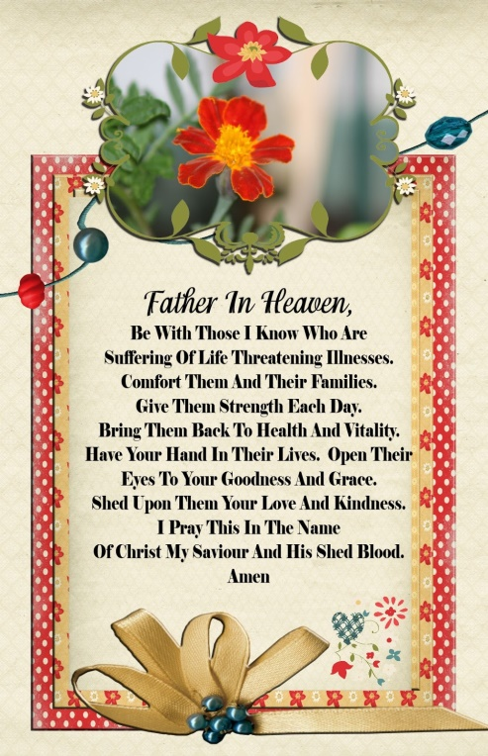

**Please also keep remembering in your prayers:-**

**Reverend Katharine, her husband Paul and son** Christopher as Katharine and Paul recover from Coronavirus.

**Edna and David Barlow** - Please still keep Edna and David in our prayers.

**Peter Caswell - Your Prayers Are Requested**       
I have recently received a diagnosis of cancer. Specifically, cancer of the prostrate. My principal carer is Delia, formerly known as Nurse Grundy, so I couldn't be in better hands.

But I am also in the care of our wonderful NHS and all the nurses and doctors who dedicate their lives to helping people like me.

When I was a child my mother would not utter the word "cancer" but always mimed it. How times have changed!

Your prayers would be appreciated but also please include those people suffering beyond the reach of professional medical care: they need your prayers more than I do. Delia and I have total confidence in all the NHS staff who will be working hard to bring me to a complete recovery.

See you all soon! With love and thanks, **Peter Caswell**

**Eileen Groves** – who is undergoing radiotherapy treatment at Christie’s. Eileen has a taxi provided to take her to Christie’s.

**ALSO** – Let us remember anyone we know of that is suffering at this time of year whether from illness, mourning or mental health problems. They are all in our prayers.

**IF THERE IS ANYONE YOU KNOW OF WHO NEEDS OUR PRAYERS PLEASE LET ME KNOW (WITH THEIR APPROVAL) AND I WILL INCLUDE THEM IN THE LIST. THEY DON’T NEED TO BE MEMBERS OF OUR CHURCH.**

**++++++++++++++++++**

**PRAYER FROM METHODIST WOMEN IN BRITAIN ONLINE –**

**Stay and Pray – The Joint Public Issues Team –**

**Today we pray for countries unable to access vaccines. The UN Secretary General has criticised the unfair distribution of CoviD vaccines, identifying that 130 countries have yet to receive a single dose. We pray for an international effort to make vaccine distribution fair and equitable, and not solely based on a country’s wealth!!!!!!!!!!!!!**

**++++++++++++++++++**

**PLEASE SEE BELOW AN EMAIL FROM REV LEN PEREIRA RE: A LENT EVANGELISM COURSE THAT HE IS ORGANISING**

**Subject: The Natural Evangelism Course**

Dear All

This is to let you know that I am planning to run a 6 week course via zoom which will roughly coincide with Lent. It is the "Natural Evangelism" course which has been produced by J John, a well-known UK evangelist.

Now I know that the word "evangelism" is enough to make most of us run for the hills, so please let me explain why I want to offer this course in particular:-

1. You have probably heard it said, and may have said it yourself, that when churches eventually reopen we must not merely return to what we were doing pre-lockdown, because if we do the world will continue to pass us by and the Church will continue to decline. One of the things we can do differently is to restore the role of evangelism to be a key part

of church life because I am sure you will agree that it has all but disappeared.

2. The purpose of the Natural Evangelism course is to help us to be more confident in situations where we have opportunity to share the good news of Jesus Christ. The clue is in the word "natural" ie the course focuses on everyday situations in which we engage with family, friends, colleagues, neighbours etc. Whilst evangelism is undoubtedly a specific

calling for some people, the course will encourage us to know that we can all contribute in some way to this important ministry.

So, if you would like to take part (and can access zoom) please do the following two things:-

1. Let me know by email.

2. Order for yourself the book called "The Natural Evangelism Course" for £5 from [www.canonjjohn.com](http://www.canonjjohn.com) **NB: make sure you order the course book and not the personal book** – they look very similar.

The Course will run on six consecutive Tuesdays at 7.30pm, starting on 2nd March and finishing on 6th April. Thanks - Len Pereira

**++++++++++++++++**

**SHARING SUNDAY WORSHIP - 10:30am**

**We are sharing our Sunday Service over the telephone, or online.**

**Online**, click this link to join via your internet browser. On a tablet or smartphone, download the Webex App, which it will prompt you to do: <https://mydanone.webex.com/mydanone/j.php?MTID=mcfe21c4f7df98fe26d8960c752cefd8b>

**OR**

**Phone**: Dial 020 3478 5289 on your telephone, When it asks for the access code, enter 145 404 825#. When it asks for your ID, press #. The call will be charged at the standard UK phone rate

**++++++++++++**

**IF YOU ARE not a member of the church and need guidance/help** please contact Delia Caswell on the phone number at the top of the first page of this news sheet.

IF YOU WOULD LIKE TO CONTRIBUTE SOMETHING TO THE NEWS SHEET PLEASE CONTACT ME ON EMAIL BY WEDNESDAY OF EACH WEEK: **christine4872@sky.com** or phone me on my Mobile – 07801252625.

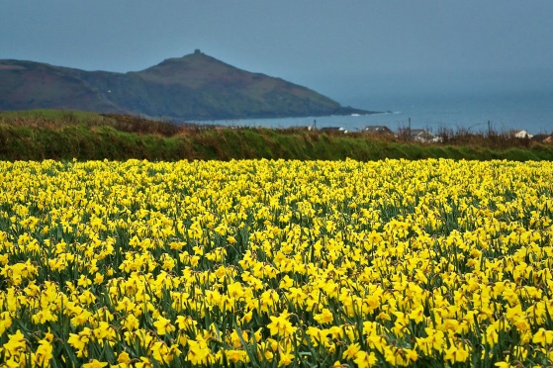 **-- WITH A LITTLE BIT OF IMAGINATION THIS COULD BE THE ISLE OF ARRAN.**